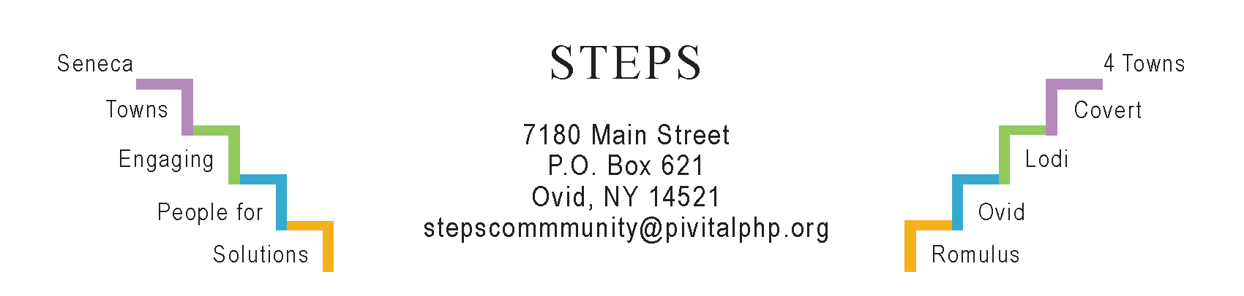

STEPS E3 Meeting Minutes

Monday, 10/23/23 (6:30 pm) by Zoom
Attendees: Ave Bauder, Jean Currie, Sara Flack, Karel Titus, Theresa Lahr, Judy Mellgard, Jan Quarles.

General Info / Reports (Ave)
- Creating Healthy Schools & Communities (Sara Flack):
- 2 new school coordinators for CHSC
- 5 daycares enrolled
- Rabies clinic 10/27 (6 pm) by pre-registration, Waterloo Fire Hall
- SC Dept of Health’s Covid vaccination guidelines: Go to PCP. If no PCP, or underinsured, go to pharmacy or outreach events.
- Free Covid test kits available, 4 per household, by mail
- Some Covid tests available at Health Dep’t & at some libraries
- Willard Task Force: About 70 ppl attended the 2nd Public Input Session Mon, Oct 2nd at SS HS. A summary of public input so far was presented. Priorities include lakefront for public use & possible hotel; a community center (possibly Hadley Hall) & with nearby bldgs for retail & entertainment; new single-family homes near the street, to expand the existing neighborhood. The next (& final) input session is Mon, Nov 13 at 5 pm; same place.
Sustainability (Karel)
- The Climate Smart Task Force could learn about ways to mitigate climate change by tuning into Brady Ferguson’s “Call Your Community Green” from the Rochester area.
- The Lodi Food 4 All pantry relocation won’t happen for several more months. At our next E3 meeting, Karel will report on the food pantry leaders’ meeting that took place on Oct 24 at Lodi Rod & Gun.
- Composting is slowing down for the season. STEPS is organizing a pumpkin repurposing option through November. To keep pumpkins out of the landfill, they can be used as compost or animal feed at the Pumpkin Patch (Ovid), Schlabach Farm (Interlaken), and Lodi Community Garden.
- Regretfully, Kyle Barnhardt resigned as Lodi Town Supervisor. Luke Latini is Deputy Town Supervisor.
- Interlaken’s “Water Tower Park” planners continue to meet monthly. Tony Del Plato and Janice Conrad are fundraising for it.
Reviews & Updates (Ave)
- Sat, Oct 14: STEPS’ Annual Day of Service. 12 organizations participated (up from 6 last year) and 53 volunteers including 8 HS students and 11 Girl Scouts. Nearly all the projects were outdoors (yard work or planting garlic). CCE’s “blender bike” was a big hit at the celebratory luncheon.
- Phase V (Theresa): STEPS (Pivital PHP) is collaborating with SCPD & CD, formally joining a coalition on a potential EPA Brownfield Assessment Grant, with STEPS’ portion to do community engagement work. If awarded, these funds will arrive in the spring. Another funding opportunity we’re exploring is the Mother Cabrini Foundation’s 2024 grant cycle, to improve health for underserved communities’ basic needs (I.e., food security & housing).
Upcoming Events / Action Items
Mon, Oct 30, Kitchen Table @ STEPS: Hannah Farley on cancer screenings.
Weds, Nov 15 (6:30-8 pm) RISERS Quarterly Gathering at STEPS’ office. Joe McGrath from SC Planning & Community Development Dep’t will present findings from the county-wide housing needs assessment. STEPS’ 2 working-group's leaders will give us some updates. Refreshments provided.
Fri, Nov 17 (3-6 pm) SC Health Fair at Seneca Falls Rec Ctr. (2-3pm set-up).
Mon, November 27 (6:30 pm) by Zoom will be our next E3 meeting.

