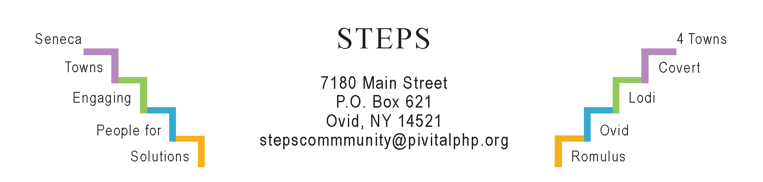

STEPS E3 Meeting Minutes

Monday, 9/25/23 (6:30 pm) by Zoom
Attendees: Ave Bauder, Jean Currie, Sara Flack, Janet Lynch, Karel Titus, Laurie Fort, Theresa Lahr, Judy Mellgard, Jan Quarles.

General Info / Reports (Ave)
- Creating Healthy Schools & Communities (Sara Flack): Radar signs to slow traffic on CR153/Kidders-Sheldrake are in the works. Adding benches & bike racks at Sheldrake Pt under consideration by Ovid Super Joe Borst. CHSC’s new liaisons: Dan Neville & Asa McMann (SS), Amanda Pundt (Romulus). Romulus is the first to book a Wellness Committee meeting.
- Willard Task Force: 2nd Public Input Session Mon, Oct 2 at SS HS Auditorium, 4:30-7:30 pm with presentation at 5 pm.
Sustainability (Karel)
- The Climate Smart Task Force met the application deadline for certification.
- The Compost Task Force will meet this TH, Sept 28, at 4 pm by Zoom.
- Interlaken’s “Water Tower Park” planners will meet Wed, Oct 4th.
- The food pantry leaders will meet on TU, Oct 24.
Reviews & Updates (Ave)
- Our 3 community gardens have been donating a lot of produce. Volunteers will plant garlic and clear beds for winter on Sat, Oct 14 (Day of Service).
- STEPS’ new Micro-E applicant, APEX Property Services, is making progress.
- Fri, Sept 1 (12n): “Community Picnic (Mark Brown) & Tree I.D. Walk” (Josh Teeter) at Lodi Point. About 70 ppl attended. STEPS co-sponsored.
- Sat, Sept 16 (6-9 pm): “Join in the Dance:” About 75 ppl attended this contradance w/live music at Brook Barn in Interlaken. Sponsored by STEPS.
- Sat, Sept 23 (10-11 am): 10 ppl enjoyed the Group Hike on the Interloken Trail of the FLX National Forest led by Ann Marie Smith of Lodi.
- Phase V (Theresa): Seeking funding for STEPS beyond July 2025.
Upcoming Events / Action Items
Sat, Oct 14: STEPS’ Annual Day of Service. Volunteers begin at 9 or 10 am & work until 12n; luncheon for all at Ovid Firehouse 12:30-1:30 pm). 12 sites with yard work or garlic planting. 50 ppl (19 of them youth) will volunteer, but we still need more. Please contact Jan Quarles: jquarles@pivitalphp.org
Mon, Oct 30 (1:30 pm) Kitchen Table @ STEPS: Hannah Farley on cancer screenings.
Weds, Nov 15 (6:30 pm) RISERS Quarterly Gathering at STEPS’ office.

Mon, October 23 (6:30 pm) by Zoom will be our next E3 meeting

