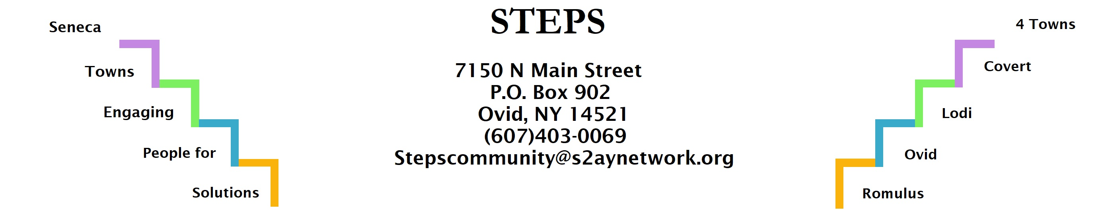

STEPS E3 Meeting Minutes
Location: | Zoom
Date: | 1/23/2023
Time: | 6:30pm
Attendees: | Theresa Lahr, Deborah Puntenney, Judy Mellgard, Kim Pollack, Ryan Staychock, Karel Titus, Bob Romick, Jan Quarles, Chris Ehlers

Discussion Items
- CCE Environmental/Natural Resources Educator Ryan Staychock shared about his new position. He mentioned that the main topics people are concerned with are: waste management, composting, recycling, energy use especially in Schuyler County, climate change, Climate Smart Communities, HABS, flood issues (Karel Titus brought this last one up).
- Lodi Food Pantry had 70 dozen eggs donated by a local grower last week. The pantry has seen its numbers double in all areas; greatest increase being adults with children.
- Climate Smart Lodi Task Force is working on flood survey, getting people signed up with community solar project, and other small projects over the winter.
- Compost Task Force is planning programming for Spring and Summer months.
- Resident Health Promotion Projects: Interlaken residents planning a barn dance (Contradance) for September.
- Winter Fest: weather wasn’t cooperative, but STEPS had a lot of participants with the pony rides. Planning for next year will include contingency plan for weather.
- Phase V/Transition: Kim Pollack leaving STEPS at the end of March
- STEPS’ Open House 1/30, 5:30-7pm
- 16 residents participated in January 14 Cooking Session. Three plant-based meals were made and enjoyed by all.
- Upcoming events: Cooking Sessions are planned for February, March, and April in Ovid, Interlaken, and Lodi respectively.

