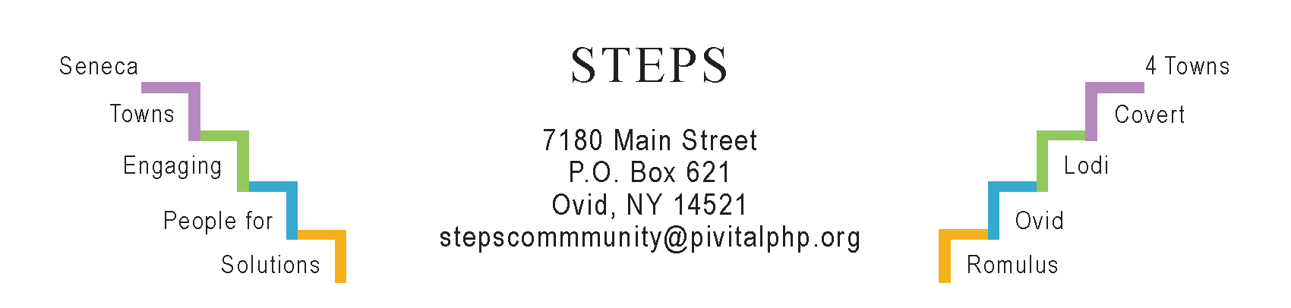

STEPS Personal Health & Wellness Meeting Minutes
Location: | STEPS Office and by Zoom
Date: | July 10, 2023
Time: | 10:30 am
Attendees, with self-intros: | Phyllis Motill (Chair), Magnolia Ariza-Nieto, Claudia Ariza, Doris DePew, Theresa Lahr, Jan Quarles. By Zoom: Sara Flack (CHSC Dir.), Kelly Kaufman (CAP), Natalia Nelson (FLX Community Health).
Presentation
Magnolia Ariza-Nieto introduced us to the CDC National Diabetes Prevention Program. She stated that 8 out of 10 don’t know they have pre-Diabetes. She asked how to reach people. Jan will include in the next STEPS E-News the CDC’s link for a quick online test. Phyllis suggested she start with the 3 libraries, as well as Seneca County DOH and Office for the Aging.
Reviews of STEPS Recent Events
STEPS tabled at all 3 Festivals in June which were very well attended. The basketball hoops in Interlaken and our Wellness Corner in Ovid were popular. Lodi Fest’s logistics will improve.
On 6/22, Pivital via Excellus Grant sponsored Judy Mellgard to co-train Mental Health First Aid.
Reports of Ongoing STEPS Activities
“Yoga in the Parks,” an RHPP, continues until 8/08, with an average of 6 attending.
“Girl Scouts Garden,” an RHPP, continues to develop in the Ovid Federated Church yard.
Janet Lynch oversees Walk ‘n Talk every Tuesday, 6 pm, at SS HS track.
“A Park for All Ages” in Interlaken: A survey was done at Interlaken Olde Home Days on 6/10. The planners (Mayor Richardson, Tony Del Plato, Janice Conrad, Jae Darling, & Theresa Lahr) will meet again at STEPS office on 7/11.
Planning Upcoming Events
Mon, July 17 (6:30-8:00 pm) RISERS Quarterly Gathering, Ovid Firehouse. Deb Puntenney will facilitate. We’ll review all that STEPS – with the community’s help -- has accomplished in the past decade and solicit residents’ ideas on moving forward beyond Phase V when our primary funding ends. Taco Bar courtesy Deb Bush.
Mon, August 14 (1:30-2:30 pm) KITCHEN TABLE community conversation at STEPS office. Linda Pacelli Dixon will lead this first one in her series of three on downsizing: “Cash in Your Closet: Your Kids Don’t Want Your China.”
Deb Bush is developing a fall event: Ryan’s Cases. No details yet.
Sat, Sept 16 (6-9pm) “Join in the Dance,” an RHPP. Contradance with live music, Brook Barn, 8228 Rte 96, Interlaken.
Sat, Oct 14 (9am-1pm) Annual Day of Service. Phyllis suggested the churches be contacted. Judy Mellgard agreed to do that. Send more ideas to Jan Quarles <jquarles@pivitalphp.org>.
Open Forum
- Public Input Open House at SS HS tonight (7/10) at SS HS – about future of Willard property.
- Mobile Mammo Unit, this Thursday, 7/13 (12n-5p), Ovid Firehouse.
- Alzheimer’s Association: New support group for caregivers, Ovid Library, 4th Weds of the month, 5:45-6:45 pm.
Next PH&W Meeting
Monday, August 7, 10:30 am at STEPS office or by Zoom. It will be Doris DePew’s birthday!

