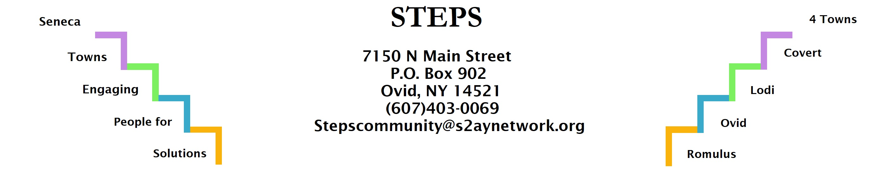

STEPS E3 Meeting Minutes
Location: | Zoom
Date: | 10/24/22
Time: | 6:30pm
Attendees: | Sara Flack, Tom Bouchard, Karen Burcroff, Jean Currie, Ave Bauder, Jan Quarles, Tony DelPlato, Lynda M., Kim Pollack

Discussion Items
- Sara Flack project director of Creating Healthy Schools and Communities gave the CHSC grant overview and shared opportunities for funding for resident-led health-centered projects.
- Willard: IDA arranged a tour of facility with DOC, Chamber of Commerce and others. $4 million was allocated from the state to keep the boilers running on minimum temperature so pipes won’t burst, etc. IDA is putting out an RFP for highest and best use study.( Ave, Tom)
- Compost: Wes Ahouse is working on establishing a compost collection site for Interlaken. Marti Macinski held a Compost Workshop at the Lodi Library on 10/22. (Tony, Kim)
- Interlaken Park: Still waiting to hear from NY Forward about grant application. (Tony)
- RHPP: Chair yoga in Interlaken Library started October 18. First class had 18 people. (Jan)
- Day of Service: Six organizations participated, with residents of all ages working at each site. (Jan)
- Community Forum on Alzheimer’s is Nov. 3, 11am-1pm at Ovid Library. (Jan)
- Next E3 Meeting Monday November 28 at 6:30pm on Zoom.
Action items | Owner(s) | Deadline | Status

