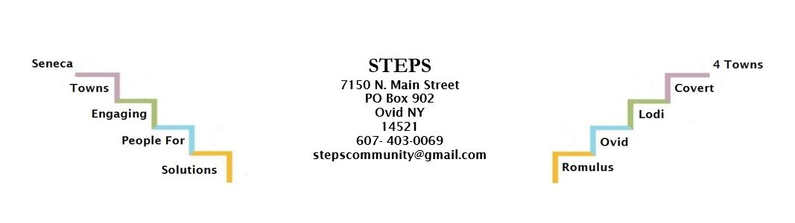Resident Health Promotion Projects (RHPPs) are neighborhood-based, small-scale community-improvement efforts that local residents design and implement with their neighbors to improve some aspect of community health and well-being. These “mini-grants” are not intended to replace funding from other more traditional streams (e.g., city or village budgets, program budgets). Rather, they are intended to encourage residents to get involved in the larger work of the local Neighborhood Health Status Improvement Initiative project.

WHAT TYPES OF PROJECTS ARE ELIGIBLE FOR SUPPORT?
- All projects that address some aspect of community health and well-being will be considered.
- This includes beautification or improvement of public spaces, activities or events for residents that address physical, social, or economic health with a positive theme.
- Realistic and well-planned projects that include as many residents as possible in planning and implementation, and as participants.
WHAT TYPES OF PROJECTS ARE NOT ELIGIBLE FOR SUPPORT?
- Projects that are not accessible to, and do not benefit the entire neighborhood; projects for which any single individual or group of individuals benefit personally.
- Projects that pay salaries to individuals; projects completed on private property (without special approval).
- Purchase of tools/equipment not available to all residents; purchase of electronic equipment such as video cameras, telephones, video/audio recorders, televisions, etc. (without special approval).
PROCESS
- Complete this application, answering each question fully and completely with as much detail as possible.
- Review the application with your community’s Project Coordinator.
- Revise as recommended, and submit for approval.
- REMEMBER, these grants are designed to improve community health, so make sure to explain how your effort will contribute broadly to a healthier community!

APPLICATION
Name of resident leader/primary applicant:
Names of other residents who will participate in planning and implementation (at least 2 others):

Name of the project:
Primary contact person:
Telephone:
Mailing Address Including ZIP Code:
Alternate Contact Person:
Telephone:
Answer all of the following questions thoroughly. Attach additional sheets if necessary to illustrate plans or details.
- Where will the project take place (e.g., neighborhood, town, village, address)?
- Describe the project you are proposing.

- Explain the health improvement issue(s) the project will address and describe how this is designed to happen.
- Describe how you will ensure that healthy foods and activities are incorporated into the project.
- How many community residents will be involved in designing and implementing the project? What will they do? What tasks and activities will they complete?
- How many community residents will participate in the event/activity the project is creating?
- What is the larger benefit of your project to the residents of the neighborhood? What is the expected impact on the physical, social, or economic health of the neighborhood?
8. If liability insurance is required for this activity, please indicate here who will provide it, and attach appropriate documentation. Otherwise indicate NA.

TOTAL FUNDING REQUESTED: $

BUDGET
Describe the budget and how this money will be spent; be sure to obtain estimates for each cost anticipated.
Primary Contact Person Signature and Date:

Alternate Contact Person Signature and Date:

Attach photos, drawings, or other types of supporting material if needed.

FOR PROJECT COORDINATOR
Please provide a brief review of the proposed RHPP and comment on how you see this project aligning with your community health improvement plan in general, and specifically in terms of its focus areas and/or activities.

Project Coordinator Signature and Date:

PROJECT AWARDED ON: (date)

