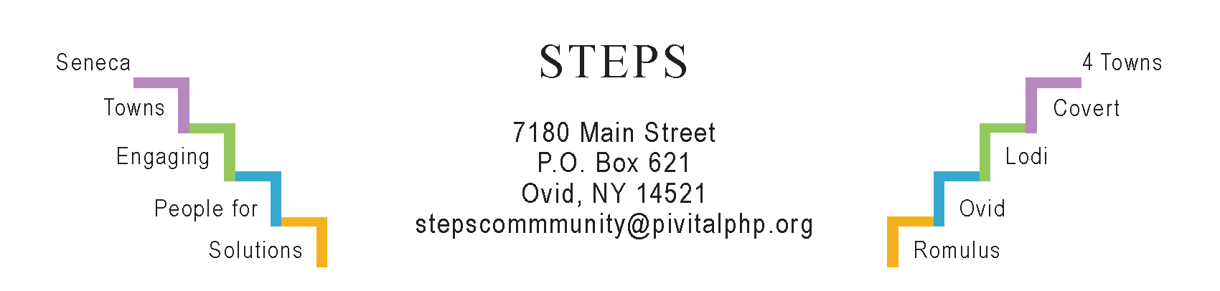

STEPS E3 Meeting Minutes

Monday, 8/28 23 (6:30 pm) by Zoom
Attendees: Ave Bauder, Karel Titus, Tom Bouchard, Karen Burcroff, Sara Flack, Theresa Lahr, Jan Quarles.

General Info / Reports (Ave)
- Creating Healthy Schools & Communities (Sara): Mini-grants w/CAP & Ovid Food Pantry (new refrigeration units); “LinkTree” at 5 websites with healthy recipes & QR code, searchable by produce item; postcards of this to distribute at all food pantries; improvements at 5 daycare centers in Sen Cty (I.e. new swing sets); working w/Ovid on Safe Streets & w/Romulus (Amanda Pundt is liaison).
- Willard Task Force: Next public input session not yet scheduled (possibly Oct 2). Applying to NYSERDA to make Hamlet of Willard a geothermal region.
- Senator Gillibrand visited Buttonwood Winery: FLX to be designated a National Heritage area; Willard to be included; Natl Park Svc funding to be available.
Sustainability (Karel)
- Lodi Food 4 All Pantry will be moving to Town Hall building soon. The pantry just received a $24K grant from Greater Rochester Health Fdn to expand their capacity. This includes hiring a bookkeeper, buying a printer & projector to train volunteers, and providing funds to reimburse volunteers for mileage.
- The Compost Task Force will report questionnaire results at next E3 mtg.
- Interlaken’s “Water Tower Park” (Theresa): Amish builder Amos Esch will quote cost of building the gazebo. Kristy Wilcox is making the sign. County Soil & Water considering retention pond to prevent flooding from adjacent creek.
Reviews & Updates (Ave)
- National Night Out 8/1 (Karen). Attended by 250 Adults + 250 kids.
- CCE’s Rain Barrel Workshop – 7/26. 15 attendees.
- AG TOUR, co-hosted by CCE, USDA, Farm Bureau, and SC Soil & Water. Farmers are trying to protect the environment through good practices.
- STEPS’ Resident Health Promotion Projects (RHPPs)
  - “Yoga in the Parks:” Average attendance: 6 people at each of the 16 sessions. Last class was 8/10 with potluck brunch afterwards.
  - Girl Scouts’ Community Garden in the Ovid Federated Church yard.
- Phase V (Theresa): In process of seeking funding for STEPS for July 2025.
Upcoming Events / Action Items
Mon, Sept 18 (1:30 pm): “Cash in Your Closet: Your Kids Don’t Want Your China,” the last of a series of 3 Kitchen Tables @ STEPS led by Linda Pacelli Dixon.
Fri, Sept 1 (12n): Community Picnic at Lodi Point Marine Park (Mark Brown); Tree I.D. Walk (Josh Teeter). BYO lawn chairs. STEPS is co-sponsoring.
Sat, Sept 16 (6-9 pm): “Join in the Dance,” a STEPS RHPP. Contradance at Brook Barn, 8228 Route 96, Interlaken.
Sat, Sept 23 (10-11am): Guided Group Hike (2.4 miles), for ages 10+, led by Ann Marie Smith. Northernmost trailhead of Interloken Trail. Call Jan for directions 607 280-7730. The FLX Natl Forest rates this trail as “easy.” Sat, Sept 30 is the rain date.
Sat, Sept 30, Hazardous Waste Day (Romulus), pre-registration required.
Sat, Oct 14 (9a-1:30p) STEPS’ Annual Day of Service. If you’d like to participate or have an idea for a project, please contact Jan Quarles: jquarles@pivitalphp.org
Mon, Oct 30 (1:30 pm) Kitchen Table @ STEPS: Hannah Farley on cancer screenings.
Tu, Oct 31: Barr Family Halloween Trail, Interlaken – more info TBA (Theresa).
Weds, Nov 15 (6:30 pm) RISERS Quarterly Gathering at STEPS’ office.

Mon, Sept 25 (6:30 pm) by Zoom will be our next E3 meeting

