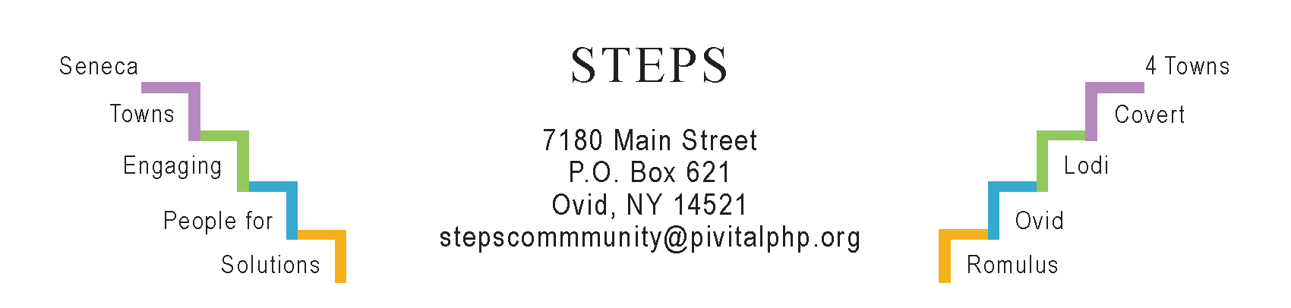

STEPS E3 Meeting Minutes

Monday, 7/24 (6:30 pm) by Zoom
Attendees: Ave Bauder, Tony Del Plato, Jean Currie, Magnolia Ariza-Nieto, Janet Lynch, Karel Titus, Deborah Puntenney, Theresa Lahr, Judy Mellgard, Jan Quarles.

General Info / Reports (Ave)
- Creating Healthy Schools & Communities: The “Blender Bike” is making its way through the schools. Assessment of Complete Streets is coming.
- Willard Task Force: Open House at SS HS drew >100 people. Next session is possibly Sept 12. Deborah recommended Greg O’Connell to consult.
- Camp Babcock-Hovey in Ovid: NYS purchased it; Seneca County Bd of Supervisors will manage it and is forming an LDC.
Sustainability (Karel)
- The Climate Smart Task Force met the application deadline for certification.
- EV charging stations to be installed near the library & town hall in Lodi.
- The Compost Task Force will report questionnaire results at next E3 mtg.
- Interlaken “Park for All Ages” (Tony): Amish builders Amos & Andy will submit bids for building a gazebo. Sign-making is in progress.
Reviews & Updates (Ave)
- CCE extended the sale on “Earth Machine” composters.
- CCE’s Rain Barrel Workshop – 7/26. The barrels hold 35 gallons
- Lodi Community Garden – youth are active there this summer
- Ovid Community Garden – Shelley & Dan Pletcher, Ann Passmore
- STEPS’ Resident Health Promotion Projects (RHPPs)
  - “Yoga in the Parks:” Average attendance: 6 people at each of the 16 sessions. Last class was 8/10 with potluck brunch afterwards.
  - Girl Scouts’ Community Garden in the Ovid Federated Church yard.
- RISERS gathering on July 17 (6:30 pm) at Ovid Firehouse drew 29 people, enthusiastic about continuing STEPS work. Strong support for: community gardens, cooking sessions, yoga classes, finding a common venue for community activities, and establishing a local walking trail.
- STEPS tabled on Aug 1 at “National Night Out” at the Rodman Lott Farm in Seneca Falls. Free transportation from Romulus in RTS buses.
- Phase V (Theresa): In process of seeking funding for STEPS for July 2025.
Upcoming Events / Action Items
Mondays 8/14, 8/28 and 9/18 (1:30 pm): “Cash in Your Closet: Your Kids Don’t Want Your China,” Kitchen Tables @ STEPS led by Linda Pacelli Dixon.
Tues, Aug 15 (3 pm): CCE’s Ag Tour w/SC Soil & Water, USDA & Farm Bureau. Ending at Boundary Breaks. Register at CCE’s website. (Ave)
Sat, Aug 26 (9a-11a): “Nature Journaling for Teens & Adults” with Laurie Rubin. Lodi Rod & Gun Club. Bring a chair, hat, and journal.
Fri, Sept 1 (12n): “Meet the Trees” at Lodi Point with Laurie Rubin. BYO lawn chairs.
Sat, Sept 16: “Join in the Dance,” a STEPS RHPP. Contradance at Brook Barn, 8228 Route 96, Interlaken. Lesson for beginners at 6 pm; dance from 7-9 pm.
Sat, Oct 14 (9a-1p) STEPS’ Annual Day of Service. If you’d like to participate or have an idea for a project, please contact Jan Quarles: jquarles@pivitalphp.org
Mon, Oct 30 (time TBA) Kitchen Table @ STEPS: Hannah Farley on cancer screenings.
Tu, Nov 14 (6:30 pm) RISERS Quarterly Gathering at STEPS’ office.
Mon, August 28 (6:30 pm) by Zoom will be our next E3 meeting

