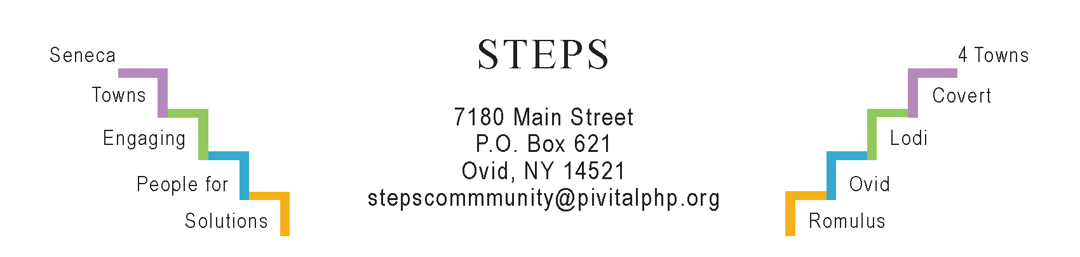

STEPS E3 Meeting Minutes

Monday, 6/26/23 (6:30 pm) by Zoom
Attendees: Ave Bauder, Karel Titus, Tony Del Plato, Brady Ferguson, Magnolia Epiwell Ariza, Karen Burcroff, Laurie Fort, Janet Lynch, Theresa Lahr, Judy Mellgard, Jan Quarles.

General Info / Reports (Ave)
- Creating Healthy Schools & Communities: Each school district received $18K/year. They have spent that money on things like grow towers, garden materials, wellness equipment, etc. South Seneca School cafeterias are composting.
- Willard Task Force: “Highest & Best Use” feasibility study is in process. The first in a series of two public input sessions will be held on July 10 (5-8 pm) in the lower cafeteria of South Seneca High School.
- Camp Babcock-Hovey in Ovid: Has 1 mile of shoreline on Seneca Lake, a pool, a Sci-Tech building & much more. NYS will purchase it from BSA; Seneca County Bd of Supervisors will form an LDC to supervise. It will likely become a public park.
Sustainability (Karel)
- The Climate Smart Task Force is hoping to meet their July deadline for certification, which will help make the Town of Lodi eligible for grants.
- EV charging stations will be installed in Lodi near the library & town hall.
- The Compost Task Force conducted questionnaires at 3 local festivals in June. Results TBA at our next E3 meeting. Live compost demos took place at all events with the “Earth Machine,” on sale for about $50 through CCE.
- NYSEG’s 10% discount for joining a solar farm wasn’t as popular as expected, possibly due to NYSEG’s extensive billing problems.
- Interlaken “Park for All Ages” (Tony): The committee conducted a public survey at the 3 festivals. Results TBA by mid-July. Tony will set up a meeting at STEPS’ office soon.
- Review of a recent Rochester “Makerspace” tour generated a discussion on the need for a space where volunteers could repair things and share their skills, as at Ithaca’s ReUse Center & Geneva’s Repair Days.
Reviews & Updates (Ave)
- Micro-E Loan: Secondary loan to APEX, a landscaping company in Lodi.
- Resident Health Promotion Projects (RHPPs)
  - “Yoga in the Parks” Tuesdays at Sampson State Park; Thursdays at Lodi Point State Park. Free.
  - Girl Scouts’ Community Garden in the Ovid Federated Church yard.
- Review of 3 festivals in June. All were well attended. Lodi Festival to be consolidated in time & space next year. In Interlaken 3 kids won bikes refurbished by Brian Quan. Ave suggested someone sell fresh strawberries next year at Ovid Strawberry Festival; Amish auction a good source.
- Ovid Farmers Market opened June 16. Fridays from 3-7 pm all season.
- Phase V (Theresa): Looking into funding for 2 years from now for STEPS. Seeking leadership training options. RISERS gathering on July 17 (6:30 pm) will summarize STEPS’ achievements and look ahead to its future.
Upcoming Events / Action Items
July 21, 22 & 23: Ave invited everyone to attend “The Addams Family” musical at South Seneca MS/HS Auditorium in Ovid.
July 24 (6:30 pm) by Zoom will be our next E3 meeting.
August 1: Karen Burcroff of SC United Way invited us all to “National Night Out” at the Rodman Lott Farm, Rte 414, Seneca Falls. RTS buses are available; one will depart at 4:30 pm from Romulus School.

