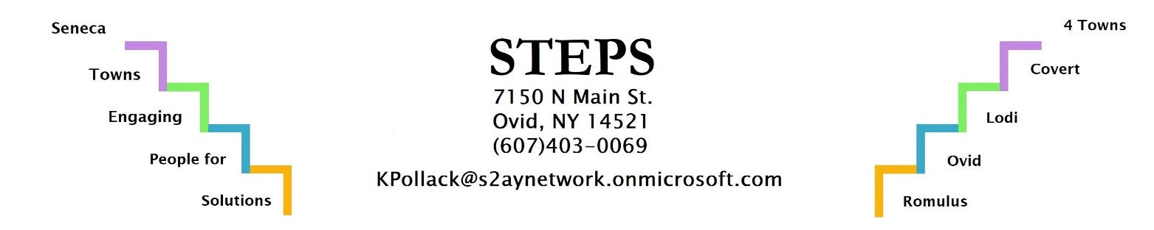

For any questions or assistance in filling out this form, please call STEPS (Seneca Towns Engaging People for Solutions) at 607-403-0069
or KPollack@S2aynetwork.onmicrosoft.com

Applicant Information
Name | Business Name
Address
Phone Number
Fax Number
Email
Business Address
Website
Business History
Describe your business idea and any steps you have taken to develop your business.

Describe any training (classes/workshops), education, or experience you have related to your business idea?

Have you completed a business plan for your potential business (please note that a business plan will be required prior to approval) If yes, please attach.

Capital Investments:

How much money have you invested in the following categories to date?

Property: $_____________

Equipment: $_____________

Inventory: $_____________

Other: $_____________

What are your funding sources, and how much did each one contribute to date?

Personal Cash: $_____________

Micro-Enterprise Grant: $_____________

Bank Loan: $_____________

Other: $_____________

Current Business Needs
List all current business expenses and liabilities below (ex. Rent, Operating Costs, Insurance, Payroll, etc.)

Funding amount requested (Up to $3,000): $_____________

What will the funds be used for?

Note: The amount awarded will be split as 50% grant and 50% loan for Micro-Enterprise Grant /Loan .

Future Goals and Community Impact
Please state two objectives for your business that you would like to see within the next two years.
1.

2.

Economic Impact

Job Impact: Note the number of full time or full-time equivalents to be created or retained by this project. Please differentiate “new” versus “retained” jobs

_____________ Jobs created if applicable

Total Yearly Business Expenditures in: Value of goods to be purchased as a result of this Microenterprise Grant/Loan

Seneca County $_____________ Seneca County $_____________
New York State $_____________ New York State $_____________

Anticipated Projected Sales:
Current Year: $_____________

Next Year: $_____________

Current assessed property value associated with your business: $_____________

Square footage of space converted to business usage sourced from: _____________

New Construction _____________

Vacant Property _____________

Private Residential Property _____________

Estimated number of new construction jobs created as a result of this project: _____________

Acres of land to be added to agricultural production as a result of this project: _____________

Acres of land to be removed from agricultural production as a result of this project: _____________

List all debt outstanding to date: _______________

How did you hear about the Micro-Enterprise Program?

Client Signature

I certify that the above information is true and correct to the best of my knowledge and understand that this information may be verified by authorized government officials.

Signature _______________________________________________ Date: _______________

Please Return this form to:
STEPS Office
PO Box 902, 7150 Main St.
Ovid, NY 14521
or email to KPollack@s2aynetwork.onmicrosoft.com

FOR OFFICE USE ONLY
Approved By:
Project Director: _____________________________________________________ Date: ______________
Sustainability Coordinator: _____________________________________________ Date: ______________
Supportive Signature 1: _______________________________________________ Date: ______________
Supportive Signature 2: ______________________________________________ Date: ______________

