1. STEPS 2018 Sustainability Forum Participant Evaluation Summary
Locate Document attachment in e-mail for 1/13/19 Event

2. Kitchen Table Sustainability: Practical Recipes for Community Engagement with Sustainability Wendy Sarkissian with Nancy Hofer et al. 2009, Earthcscan, Sterling, Virginia.
This excellent Handbook links STEPS Mission of Engaging People for Solutions to workable approaches and methods to support learning for a sustainable community future and will be shared at our 1/23 Meeting.

3. Regional Climate Change Educational Initiative
With Gay Nicholson’s support, we have been reflecting on the Sustainable Tompkins 2013 Climate Smart & Climate Ready Conference to consider how we might adapt their framework regarding what our Education and Preparedness programs might look like relative to themes, presenter expertise, and approaching targeted sectors of our community for both project engagement and our education goals. Locate Document attachment in e-mail for 1/13/19 Event

4. The Paleontological Research Institution/Cayuga Nature Center. PRI has recently published The Teacher-Friendly Guide to Climate Change. https://www.priweb.org/downloads/pubs/TFG-ClimateChange-Complete.pdf
Recommended: Chapter 7: Climate Change Mitigation Land Use: Forests, Soils, Agriculture, pp. 170-177; Chapter 9: Climate Change Adaptation pp. 196-197 (Adaptive Strategies), pp. 202-204 (Heavy Rainfall); Chapter 10: Obstacles to Addressing Climate Change pp. 213-221

PRI Climate Change Education Manager, Ingrid Zabel, is the Curator of the New York Climate Change Clearing House Website: Identify Problems, Investigate Solutions, Take Action https://nyclimatescience.org

4. Climate Change and Social Determinants of Health: Innovating Climate Policy
Sabrina Dekker, ICCG: ICCG Reflection No. 19/February 2014
http://www.iccgov.org/wpcontent/uploads/2015/05/19_ICCG_Reflection_February_2014.pdf

Table 2. Climate Change Impacts on the Social Determinants of Health

Social Determinants of Health: General socioeconomic, cultural and environmental | Climate Change Impact on SDH
Agriculture and Food Production | Decreased food yields, contributing to malnutrition, rising food costs
Education | This is a complex relationship; Lack of education can result in behaviors/practices that perpetuate climate change, while climate change affecting families can result in the early withdrawal of children from school. Other indirect causal pathways
Work Environments | Unsafe working conditions, loss of employment, risk of death and injury
Living and Working Conditions | Quality of buildings; safety; hazards; working hours, other indirect impacts
Unemployment | Indirect, loss of income reduces the purchasing power of individuals and households.
Water and Sanitation | Salination of water, compromised sanitation systems, spread of disease
Healthcare services | Impeded, stressed during times of emergency response
Housing | Loss of housing, damage to housing
5. The 4th Leg of Sustainability: Culture, Values and Identity: A definition and diagram about sustainability which we think suits STEPS has been offered by Norman Christopher, Director, Office of Sustainability Practices, Grand Valley State University in Michigan. https://wmsbf.wordpress.com/2016/11/07/christopher-what-does-sustainability-really-mean/

The 4th leg is about culture, values, and identity. It is about a sense of place that each one of us has as an individual, with our families, with the companies and organizations that employ us, and with the communities where we live and serve. To become more sustainable, there are a number of values that support this improved decision making; stewardship, connectedness, service, transparency, and creativity.”

6. Deep Adaptation: A Map for Navigating Climate Tragedy
Professor Jem Bendell BA (Hons) PhD
IFLAS Occasional Paper 2, www.iflas.info
July 27, 2018

Dr. Jem Bendell is the retired Founder of the Institute for Leadership and Sustainability (IFLAS) at the University of Cumbria (UK). Given the real peril, he suggests we are facing, he suggests that Sustainability Initiatives be focused on a deep adaptation agenda of resilience, relinquishment and restoration based on three questions that might contribute to our considerations:

How do we keep what we really want to keep?
What do we need to let go of in order to not make matters worse?
What can we bring back to help us with coming difficulties and tragedies?

Jem Bendell Article on Deep Adaptation in the face of climate change is online at his website here: https://jembendell.wordpress.com/2018/07/

7. Models of Sustainability
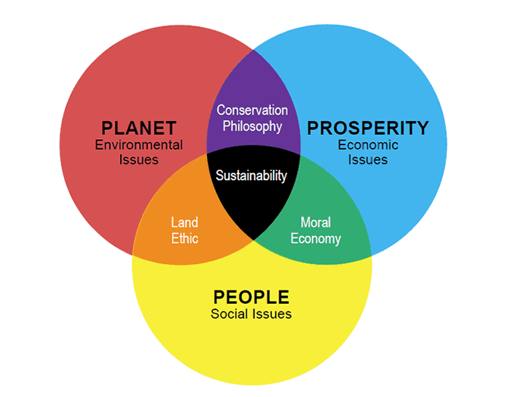  Model includes Cultural Values related to conservation, land ethic and moral economy at the heart of sustainability. (Source of diagram may be from Adam Werbach’s book True Sustainability) | 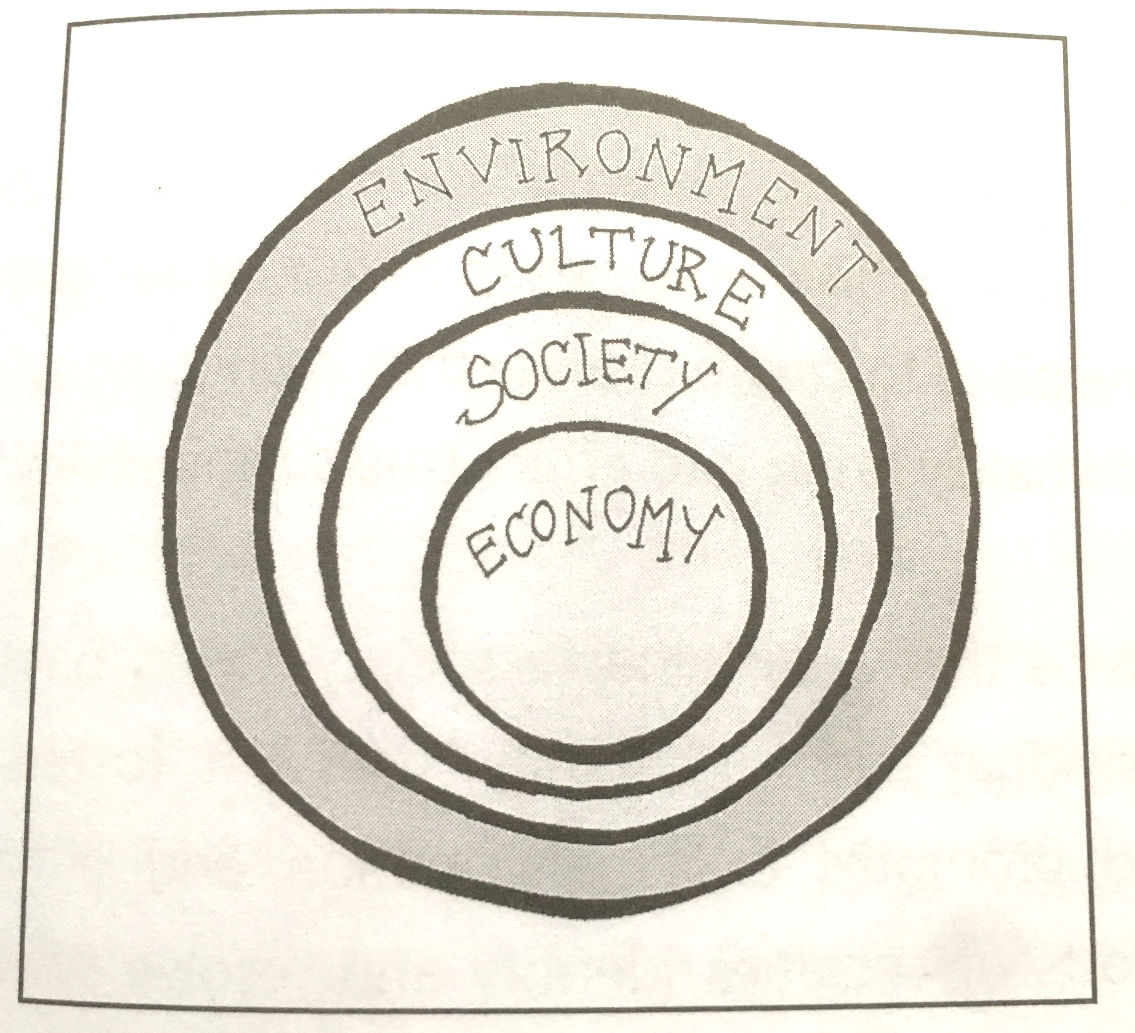  The Concentric Circles Model of Sustainability with embedded hierarchy indicative of our dependence on earth. Lowe (1994)

