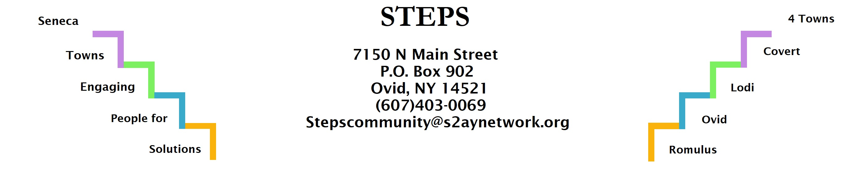

STEPS E3 Meeting Minutes
Location: | Zoom
Date: | 3/27/23
Time: | 7-8pm
Attendees: | Janet Lynch, Tom Bouchard, Natalia Nelson, Theresa Lahr, Deborah Puntenney, Jean Currie, Karel Titus, Jan Quarles, Judy Mellgard, Ave Bauder, Kim Pollack

Discussion Items
- CHSC: The director Sarah Flack is back from maternity leave. (Ave) Walkability feasibility study in Ovid might be funded by CHSC. (Theresa)
- Willard Task Force: Meet 3rd Thursday of each month; IDA selected consultant, MRB Group from Rochester, to conduct the highest and best use study. Empire State Development Realtor got a tour. (Ave)
- Climate Smart Communities: Lodi group working toward certification in July; trying to get other communities to join in to the program. (Karel) Localized Climate Stewards program to start late summer/early fall. (Ave)
- Compost Task Force: working on educating and informing the public about composting; going to have composting at Lodi Festival, Interlaken Old Home Days, and the Ovid Strawberry Festival. (Karel)
- Landscape to Lake Workshop: 45 people attended onsite and 12 online; presentations about HABS (biology, chemistry, history); potential for CCE to conduct a survey or surveys about financial effects of HABS especially on fishing/what people are willing to put up with; watch for interviews with Ted Baker; not many farmers showed up, but a few did. (Ave)
- Microenterprise Event on March 8th: 3 business owners showed up; one business owner followed up with OSBDC the next day. (Theresa)
- RHPPs: Lodi Festival was awarded theirs. (Theresa); another one involving kids growing vegetables and herbs to give to the Ovid Food Pantry is in the works. (Jan)

- Upcoming events: Risers April 17th 6:30pm at STEPS office. Alys Mann will present an analysls from village observations, plus E3 and PHW Workgroups will share updates; Mary Joslyn is possibly planning a circuit training event for teens at Firehouse Distillery on or around Earth Day;(Theresa) Open House at Romulus Town Hall on April 27th, 4-7pm, an interactive meeting to share about the updated comp plan;(Tom) Mental Health Walk with teens planned for May 13th. (Theresa)
- Next Meeting April 24th, 2023, 6:30pm on Zoom

