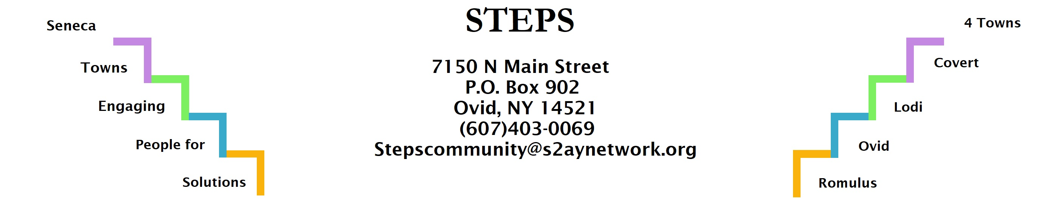

STEPS Nov. 2022 E3 Meeting Minutes
Location: | Zoom
Date: | 11/28/22
Time: | 6:30pm
Attendees: | Karel Titus, Jean Currie, Tom Bouchard, Deborah Puntenney, Ave Bauder, Theresa Lahr, Kim Pollack, Janet Lynch

Discussion Items
- Creating Healthy Schools & Communities: Lodi Food Pantry received 1 mini grant and Lodi Community Garden received 1 mini grant from CHSC. (Karel) Town of Romulus received $5000 grant for Complete Streets from CHSC. (Tom).
- Willard Task Force: highest and best use study being done. (Ave)
- Babcock Hovey Boy Scout Camp up for sale. Group trying to get NYS to buy property, listed for $9 million. (Ave)
- Lodi Climate Smart Community Task Force is focused on small projects over the winter. (Karel)
- Hilary Lambert shared neighborhood resilience resources, ways we can help each other. Hilary has compiled a lot of contact info. (Theresa & Karel)
- Compost: 1 local youth interested in composting, working on pilot program with Marti. (Theresa)
- CCE Natural Resources Environmental Educator starts 12/1/22. His name is Ryan Staychock. (Ave)
- Phase V Plan/Transition: STEPS office is moving to 7180 Main St. We’ll hold our in-person Risers gathering in our new office on 1/30/23. Details TBA. (Theresa)
- Vandana Shiva film discussion: it was an excellent discussion and we will continue discussing some of the topics in future Kitchen Table events. (Deborah, Theresa, Kim)
- Alzheimer’s event is being rescheduled for March. Details TBA. (Theresa)
- Cooking Sessions with Meg Jastran start up on 1/14/23. (Theresa)

