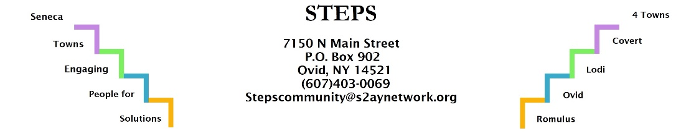

STEPS Day of Service 2019

Volunteer Information Form
October 5, 2019
8:30 a.m -2 p.m.

Please provide the following information and email or return this form to the address below. Thank you.

Please check one:

________ Yes, we are interested in participating. ________ No, we are unable to participate.

Name of Volunteer: ________________________________________________________

Any Special Skills: _____________________________________________________________

Phone Number: __________________ e-mail: ____________________________

Address: ________________________________________

________________________________________

Shirt Size:

______________________________________________________________________________

______________________________________________________________________________

Please return this form ASAP to:

STEPS
PO Box 902 email:

Ovid, NY 14521 kristin.parry@s2aynetwork.org

Attn: Day of Service 2019

THANKS FOR YOUR HELP!

